Name: Muhammad Uzair

Roll No. L1F18BSCS0311

Section - F

Apply DFS on the following graphs and mark every vertex with **[parent/d time/f time],** also mark every edge as **[tree, back, cross, forward], also show the stack along side for DFS for every graph.  
  
Start vertex for the DFS is C [Alphabatical order] [10 + 10 + 5]**

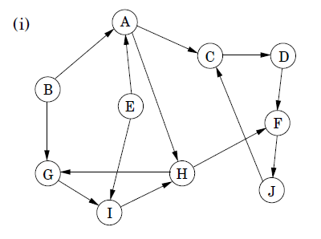

Nil / 17/ 18

Nil / 9 / 16 161616

Nil / 1 / 8

Nil / 19 / 20

**Start vertex for the DFS is E [reverse Alphabatical order] [10 + 10 + 5]**

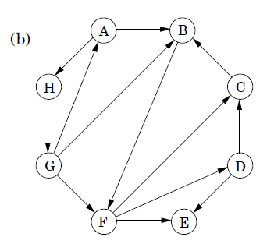

Nil / 3 / 16

Nil / 1 / 2